How to create stunning infographics with NotebookLM (in minutes)
Turn your guides, notes, and content into professional visuals without touching design software.
Dec 04, 2025

NotebookLM just dropped an infographic generator.
And it’s really good.
You can now take any source material you have in NotebookLM—guides, transcripts, research, course material—and generate detailed, styled infographics right inside the tool.
For anyone doing content operations, this is a nice addition to your workflow. Visuals matter. And now one of the best AI research tools has this built in.
Here’s how to use it.

Paid subscribers get the full written step-by-step guide below, plus all resources and digital assets used in my videos.

Step 1: Set up your notebook with source material
Before you can generate anything, you need content in NotebookLM.
Go to NotebookLM and create a new notebook. Add your source—this can be a document, pasted text, a link, or multiple sources.
How-to guides and step-by-step content work particularly well for infographics, but you can use anything.
Once your source is loaded, you’ll see the normal NotebookLM interface: source on the left, summary in the middle, and the new feature options on the right—including the Infographic button.

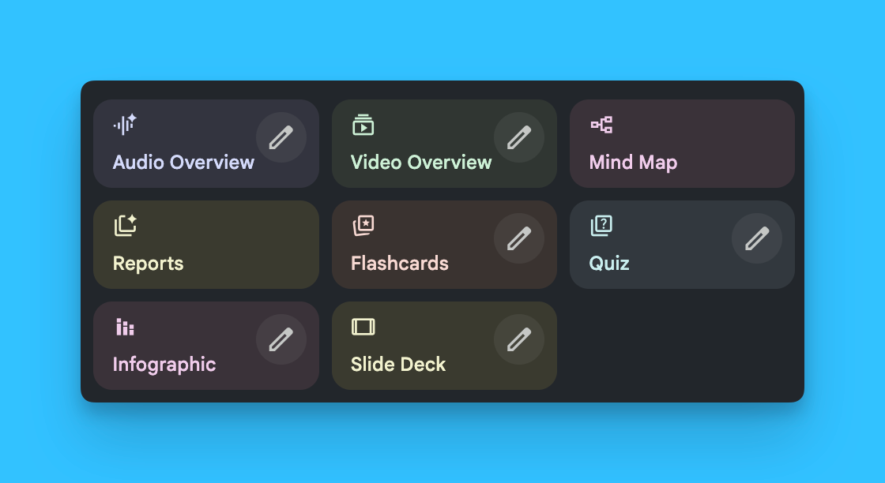

Step 2: Choose your generation method (one-shot or custom)
NotebookLM gives you two ways to generate infographics.
One-shot method: Click the Infographic button directly. NotebookLM will generate an infographic based on whatever Gemini thinks works best for your content. This is fast and the results are surprisingly solid.
Custom method: Click the edit button to access style guidelines. This gives you control over:
- Language (multiple options available)
- Orientation (landscape, portrait, or square—square works great for LinkedIn)
- Level of detail (concise, standard, or detailed)
- Style description (your own prompt for the visual style)
I recommend the custom method. The style description field is where you get real control over the output.

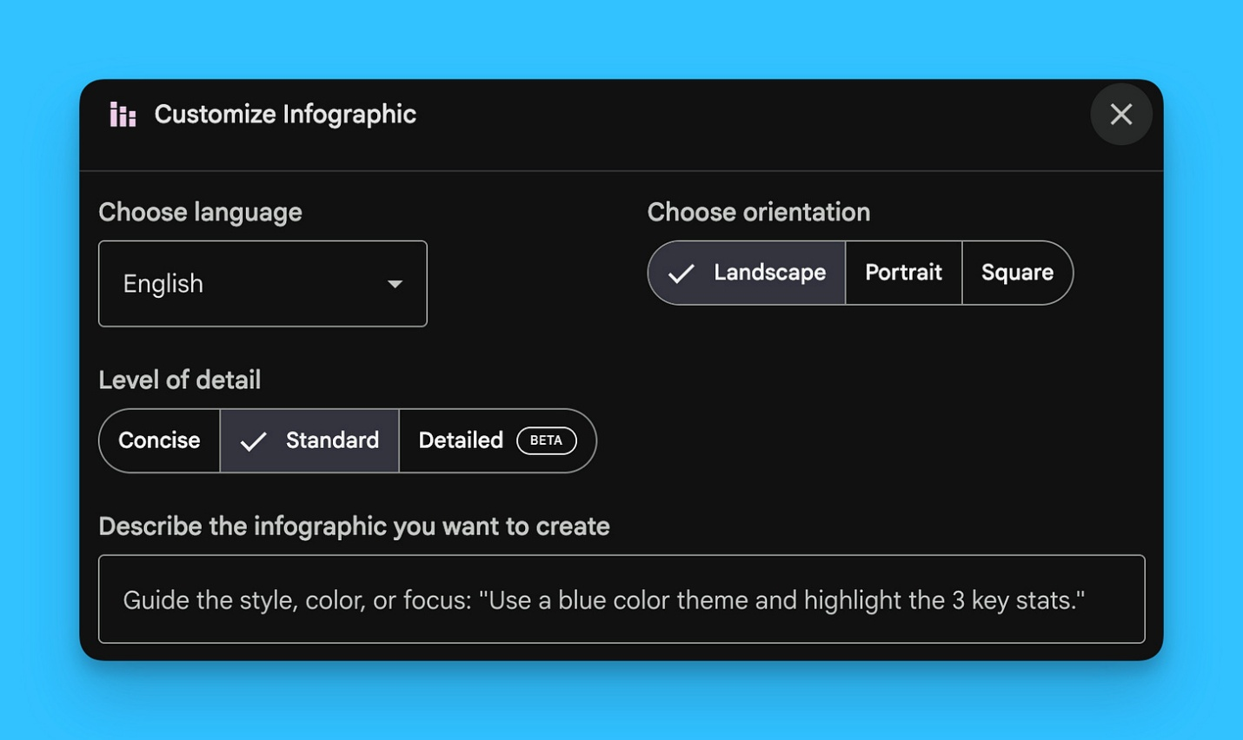

Step 3: Use style prompts for better results
The style description field accepts prompts that shape how your infographic looks and feels.
Instead of leaving it blank or writing something generic, use specific style instructions. For example:
- A step-by-step style creates process-oriented layouts with numbered steps in a visual flow
- A warm and approachable style makes the content less intimidating—softer colors, more accessible language, easier on the eyes
- A minimalist style strips away complexity for clean, focused visuals
- A data-driven style works well for content with numbers and statistics
The style you choose should match your content type and audience. A technical guide might work better with a clean step-by-step layout. A beginner-friendly piece might benefit from a warm, approachable style.

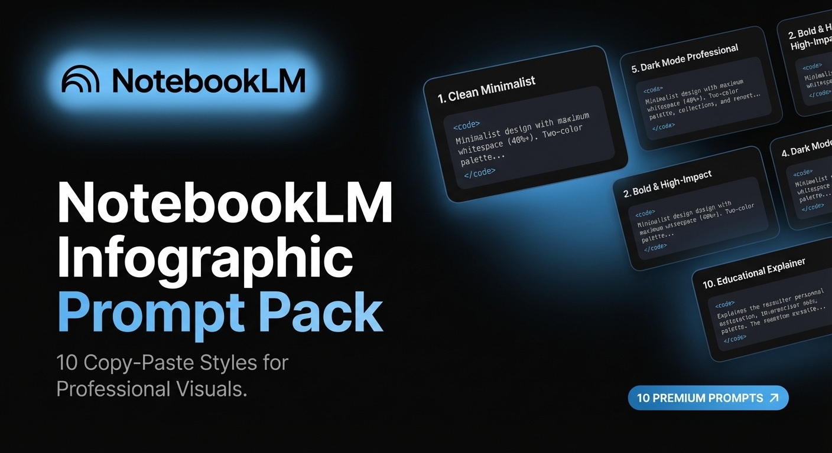

For subscribers: I put together a NotebookLM Infographic Prompt Pack with 10 different style prompts you can copy and paste directly into NotebookLM. Each one is designed for specific content types and situations.
→ Click here to access the NotebookLM Prompt Pack

Step 4: Generate and compare variations
Run multiple generations with different styles to see what works.
Generate a few infographics using different style prompts. The results will appear on the right side of NotebookLM. Compare them—you’ll notice how different styles change not just the visuals, but also the language and structure.
For example, a technical how-to might generate a title like “5 Steps to Set Up Claude Code for AI Writing” with one style. With a warm and approachable style, the same content might generate “How to Build Your AI Writing Second Brain”—more accessible for people who aren’t as technical.

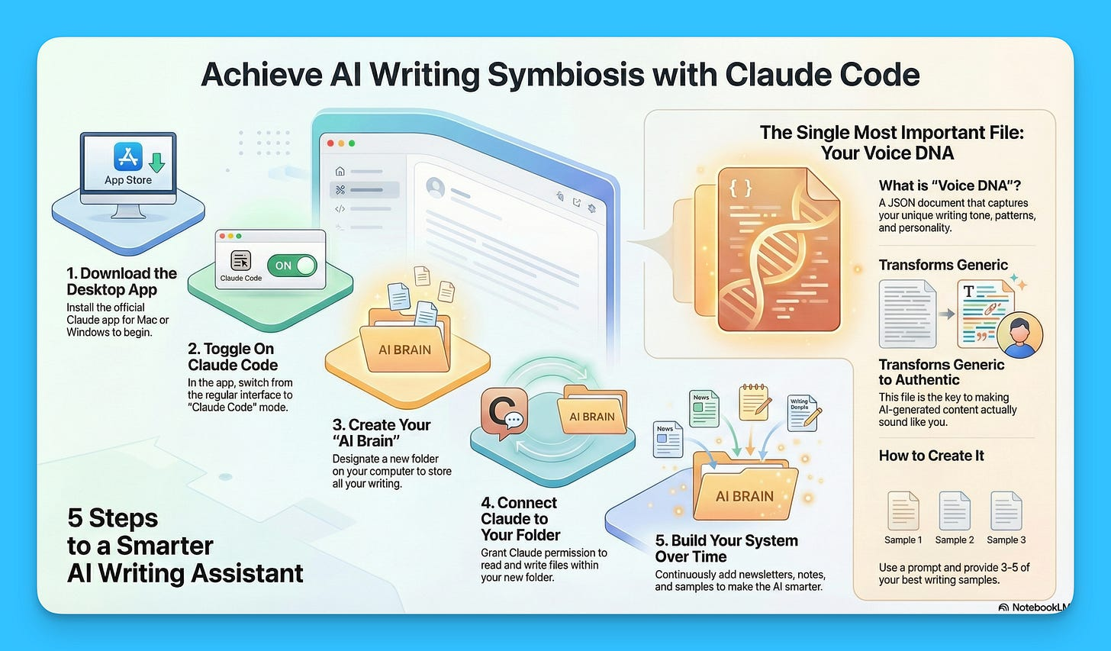
Infographic I created based on one of my Substacks
Quick tip: Click “show prompt” in the top right corner of any generated infographic to see exactly which prompt was used. Helpful for tracking what worked.

Step 5: Download and use
Once you have an infographic you like, download it.
Click the download button on any generated infographic. You can use these for newsletters, social posts, course materials, client deliverables—anywhere you need a quick visual that actually looks good.
A note on the detail setting: I recommend keeping it on “standard” or even “concise.” The detailed option can overload the infographic with text and make it harder to read. More isn’t always better here.

NotebookLM is one of the more useful tools in the AI writing stack. The infographic feature is genuinely helpful for content operations—quick visuals without the design overhead.
Try it with your next how-to guide or step-by-step content. And if you’re a subscriber, don’t forget to grab the Infographic Prompt Pack for ready-to-use styles.

